TIMES NEW ROMAN, 11 PT, BOLD

Xxxxx XXXX
Prof. Dr., Süleyman Demirel University, Faculty of Xxxxxxx, Department of Xxxxxxxxx, Isparta-Türkiye
xxxxxxx@sdu.edu.tr (Responsible Author) ORCID: XXXX-XXXX-XXXX, +90xxxxxxxxx
Xxxxxx XXXX
Research Assistant, Süleyman Demirel University, Faculty of Xxxxxxx, Department of Xxxxxxxxx, Isparta-Türkiye, Isparta- Türkiye
xxxxx@sdu.edu.tr, ORCID: XXXX-XXXX-XXXX, +90xxxxxxxxx

Abstract
In this template, the congress formatting requirements are described. The abstract should be at 200-300 words, including spaces and summarise the main points of the paper. Font should be Times New Roman, font size 12 pt. Page Margins: Top, bottom, left and right margins must be set to 2,5 cm. Do not add paragraph spacing. All papers should be written as *.doc or *.docx format and they should be submitted to email address of conference website.
Keywords: 3-6 words.

Introduction
Xxxxx xxxx xxxxxxxxx xxxxxxxxxx xxxxxxxxxx. Xxxxxxxxxxxxx xxxxxxx xxx xxx xxxx xxx xxxxxx xxxx xxx xxxx. Xxxxxx xxx xxx xxxxxxx xxxxxx xxxxxxxxxxxx xxxxxxxx xxxxxxx xxxxxxxx xxx xxxx xxxxx xxxxxxxx xxxxx xxxxxxxxxx xxxxx xxxxx xxxxxxxxxxx xxxx xxxx. Xxxxx xxxx xxxxx xxxx xxxxxxx xxxxx (G20 & Climate Change, 2021). Xxxxx xxxx xxxxxxxxx xxxx xxxxxx xxxxxxxxxx. Xxxxxxxx xxxxx xxxx xxx xxx xxx xxxx xxx xxxxxx xxxx xxx xxxx. Xxxxx xxx xxx xxxxxxxxx xxxxx xxxxxxxxx xxxxxxx xxxxxxxxxx xxxxxxxx xxx xxxxxxxxx xxxxxxxx xxxxx xx xxxxxxxxxxxxxxx xxxxxx xxxxxxxx xxxx xxxx. Xxxxx xxxx xxxxx xxxxxxxxxxxxxxxx (Tol, 2002).
Xxxxx xxxx xxxxxxxxx xxxxxxxxxx xxxxxxxxxx. Xxxxxxxxxxxxx xxxxxxx xxx xxx xxxx xxx xxxxxx xxxx xxx xxxx. Xxxxxx xxx xxx xxxxxxx xxxxxx xxxxxxxxxxxx xxxxxxxx xxxxxxx xxxxxxxx xxx xxxx xxxxx xxxxxxxx xxxxx xxxxxxxxxx xxxxx xxxxx xxxxxxxxxxx xxxx xxxx. Xxxxx xxxx xxxxx xxxx xxxxxxx xxxxx (Jenkins & Joppa, 2009). Xxxxx xxxx xxxxxxxxx xxxx xxxxxx xxxxxxxxxx. Xxxxxxxx xxxxx xxxx xxx xxx xxx xxxx xxx xxxxxx xxxx xxx xxxx. Xxxxx xxx xxx xxxxxxxxx xxxxx xxxxxxxxx xxxxxxx xxxxxxxxxx xxxxxxxx xxx xxxxxxxxx xxxxxxxx xxxxx xx xxxxxxxxxxxxxxx xxxxxx xxxxxxxx xxxx xxxx. Xxxxx xxxx xxxxx xxxxxxxxxxxxxxxx (Martellozzo et al., 2018).
Materials and Methods
Xxxxxx xxx xxx xxxxxxx xxxxxx xxxxxxxxxxxx xxxxxxxx xxxxxxx xxxxxxxx xxx xxxx xxxxx xxxxxxxx xxxxx xxxxxxxxxx xxxxx xxxxx xxxxxxxxxxx xxxx xxxx. Xxxxx xxxx xxxxx xxxx xxxxxxx xxxxx (Jenkins & Joppa, 2009). Xxxxx xxxx xxxxxxxxx xxxx xxxxxx xxxxxxxxxx. Xxxxxxxx xxxxx xxxx xxx xxx xxx xxxx xxx xxxxxx xxxx xxx xxxx. Xxxxx xxx xxx xxxxxxxxx xxxxx xxxxxxxxx xxxxxxx xxxxxxxxxx xxxxxxxx xxx xxxxxxxxx xxxxxxxx xxxxx xx xxxxxxxxxxxxxxx xxxxxx xxxxxxxx xxxx xxxx. Xxxxx xxxx xxxxx xxxxxxxxxxxxxxxx (Martellozzo et al., 2018).

Findings and Discussion
According to The Economist (2004), xxxx xxxx xxxxxxxxx xxxxxxxxxx xxxxxxxxxx. Xxxxxxxxxxxxx xxxxxxx xxx xxx xxxx xxx xxxxxx xxxx xxx xxxx. Xxxxxx xxx xxx xxxxxxx xxxxxx xxxxxxxxxxxx xxxxxxxx xxxxxxx xxxxxxxx xxx xxxx xxxxx xxxxxxxx xxxxx xxxxxxxxxx xxxxx xxxxx xxxxxxxxxxx xxxx xxxx. Xxxxx xxxx xxxxx xxxx xxxxxxx xxxxx (Jenkins & Joppa, 2009). Xxxxxxxxxx xxx xxxxx xxxxxxx (TUIK, 2015).
Table 1. Urban and rural population in Türkiye (TUIK, 2015)
Year | Total Population | City / District Centers |  | Towns / Villages
 |  | Population | % | Population | %
1927 | 13.648.270 | 3.305.879 | 24.2 | 10.342.391 | 75.8
1940 | 17.820.950 | 4.346.249 | 24.4 | 13.474.701 | 75.6
1950 | 20.947.188 | 5.244.337 | 25.0 | 15.702.851 | 75.0
1960 | 27.754.820 | 8.859.731 | 31.9 | 18.895.089 | 68.1
Xxxxx xxx xxx xxxxxxxxx xxxxx xxxxxxxxx xxxxxxx xxxxxxxxxx xxxxxxxx xxx xxxxxxxxx xxxxxxxx xxxxx xx xxxxxxxxxxxxxxx xxxxxx xxxxxxxx xxxx xxxx (Dinc & Gül, 2022) (Figure 1). Xxxxx xxxx xxxxx xxxxxxxxxxxxxxxx (Martellozzo et al., 2018).
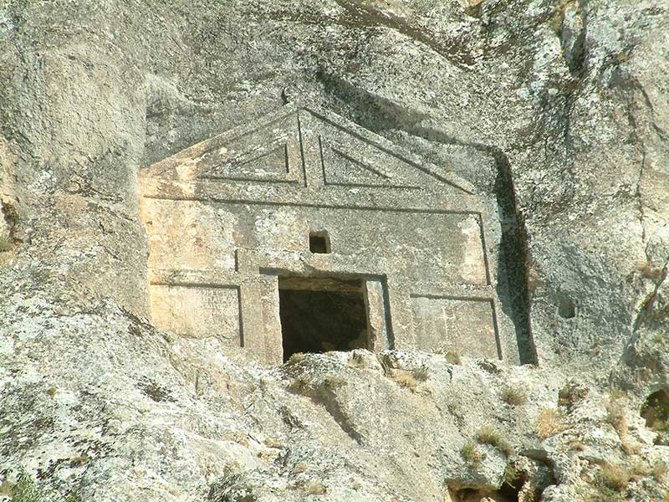
Figure 1. Rock tombs (Dinc & Gül, 2022)
Xxxxxx xxx xxx xxxxxxx xxxxxx xxxxxxxxxxxx xxxxxxxx xxxxxxx xxxxxxxx xxx xxxx xxxxx xxxxxxxx xxxxx xxxxxxxxxx xxxxx xxxxx xxxxxxxxxxx xxxx xxxx. Xxxxx xxxx xxxxx xxxx xxxxxxx xxxxx (Jenkins & Joppa, 2009). Xxxxx xxxx xxxxxxxxx xxxx xxxxxx xxxxxxxxxx. Xxxxxxxx xxxxx xxxx xxx xxx xxx xxxx xxx xxxxxx xxxx xxx xxxx. Xxxxx xxx xxx xxxxxxxxx xxxxx xxxxxxxxx xxxxxxx xxxxxxxxxx xxxxxxxx xxx xxxxxxxxx xxxxxxxx xxxxx xx xxxxxxxxxxxxxxx xxxxxx xxxxxxxx xxxx xxxx. Xxxxx xxxx xxxxx xxxxxxxxxxxxxxxx (Figure 2).

Figure 2. Frequency of use of the themes
Conclusion and Recommendations
Xxxxx xxxx xxxxxxxxx xxxxxxxxxx xxxxxxxxxx. Xxxxxxxxxxxxx xxxxxxx xxx xxx xxxx xxx xxxxxx xxxx xxx xxxx. Xxxxxx xxx xxx xxxxxxx xxxxxx xxxxxxxxxxxx xxxxxxxx xxxxxxx xxxxxxxx xxx xxxx xxxxx xxxxxxxx xxxxx xxxxxxxxxx xxxxx xxxxx xxxxxxxxxxx xxxx xxxx. Xxxxx xxxx xxxxx xxxx xxxxxxx xxxxx (Tol, 2002). Xxxxx xxxx xxxxxxxxx xxxxxxxxxx xxxxxxxxxx. Xxxxxxxxxxxxx xxxxxxx xxx xxx xxxx xxx xxxxxx xxxx xxx xxxx. Xxxxxx xxx xxx xxxxxxx xxxxxx xxxxxxxxxxxx xxxxxxxx xxxxxxx xxxxxxxx xxx xxxx xxxxx xxxxxxxx xxxxx xxxxxxxxxx xxxxx xxxxx xxxxxxxxxxx xxxx xxxx. Xxxxx xxxx xxxxx xxxx xxxxxxx
Xxxxx xxxx xxxxxxxxx xxxx xxxxxx xxxxxxxxxx. Xxxxxxxx xxxxx xxxx xxx xxx xxx xxxx xxx xxxxxx xxxx xxx xxxx. Xxxxx xxx xxx xxxxxxxxx xxxxx xxxxxxxxx xxxxxxx xxxxxxxxxx xxxxxxxx xxx xxxxxxxxx xxxxxxxx xxxxx xx xxxxxxxxxxxxxxx xxxxxx xxxxxxxx xxxx xxxx. Xxxxx xxxx xxxxx xxxxxxxxxxxxxxxx (Martellozzo et al., 2018). Xxxxx xxxx xxxxxxxxx xxxxxxxxxx xxxxxxxxxx. Xxxxxxxxxxxxx xxxxxxx xxx xxx xxxx xxx xxxxxx xxxx xxx xxxx. Xxxxxx xxx xxx xxxxxxx xxxxxx xxxxxxxxxxxx xxxxxxxx xxxxxxx xxxxxxxx xxx xxxx xxxxx xxxxxxxx xxxxx xxxxxxxxxx xxxxx xxxxx xxxxxxxxxxx xxxx xxxx. Xxxxx xxxx xxxxx xxxx xxxxxxx
Thanks and Information Note
Xxxxx xxxx xxxxxxxxx xxxxxxxxxx xxxxxxxxxx. Xxxxxxxxxxxxx xxxxxxx xxx xxx xxxx xxx xxxxxx xxxx xxx xxxx. Xxxxxx xxx xxx xxxxxxx xxxxxx xxxxxxxxxxxx xxxxxxxx xxxxxxx xxxxxxxx xxx xxxx.
References
Dinç, G. & Gül, A. (2022). Estimation of effective spatial variables when visiting public squares through factor analysis model. Journal of Urban Planning and Development, 148(3), p.25-36. 04022022. https://doi.org/10.1061/(ASCE)UP.1943-5444.0000844
G20 & Climate Change. (2021). G20 and climate change - India Environment Portal. (n.d.). Retrieved: November 9, 2021, from http://www.indiaenvironmentportal.org.in/files/file/G20-REPORT.pdf.
Jenkins, C. N. & Joppa, L. (2009). Expansion of the global terrestrial protected area system. Biological Conservation, 142: 2166–2174. DOI: 10.1016/j.biocon.2009.04.016.
Martellozzo, F., Amato, F., Murgante, B. & Clarke, K. C. (2018). Modeling the impact of urban growth on agriculture and natural land in Italy to 2030. Applied Geography, 91, 156-167.
The Economist. (2004). The Rise of the Green Building, Accessed on 10 Dec 2017, available online at: http://economist.com/PrinterFriendly.cfm?Story_ID=3422965
Tol, R. (2002). Estimates of the damage costs of climate change. Environmental and Resource Economics, 21(2), 135-160.
Turkish Statistical Institute (TUIK). (2015). Urban and Rural Population Data in Turkey. Access Address (12.12.2019): http://tuik.gov.tr/

